- Purpose
This Work Instruction outlines the validation package that is included with ReportRighter.
- Parent Documents

Document Number | Title
SOP5001 | ReportRighter
SVP5001 | ReportRighter Software Validation Protocol

- Child Documents

Document Number | Title
VA5001c | ReportRighter Validation Walkthrough

- Responsibility
  - It is the responsibility of the Software Validation Engineer to ensure that all documentation relating to the use and validation of ReportRighter is up to date and correct.
- Necessary Equipment and Resources
  - ReportRighter is a paid Microsoft Office add-in, a subscription to ReportRighter, Microsoft Word, and Microsoft Excel are necessary to use ReportRighter.
  - The ReportRighter validation protocol and addendum can be found online at www.engsuite.org/reportrighter/validation. To download both documents press the download validation package button, a .zip folder will be downloaded to your computer containing both documents. Each document can be downloaded separately by clicking the individual download links, this is a good option if you do not want to extract files from the .zip folder.
    - NOTE: The protocol and addendum are needed to validate ReportRighter.
  - All documentation for ReportRighter can be found at www.engsuite.org/reportrighter/documentation. To download all of the documentation simultaneously click the download all in the upper right corner of the page, this will download all documentation as Microsoft Word or Excel documents, depending on the document, inside of a .zip folder.
- Pre-Executed Validation
  - As part of our commitment to providing quality software, we have included an executed validation for ReportRighter in the documentation. If your organization can use this as proof validation it is available to you at www.engsuite.org/reportrighter/documentation/#executed.
- Validation Scope
  - The validation protocol is designed to test all functionality of ReportRighter. The built-in capabilities and features of Microsoft Word and Excel are not within the scope of this validation.
- Installation Qualification
  - The IQ is designed to verify that ReportRighter has been successfully purchased and deployed into the users Microsoft runtime.
  - All IQ test cases are manual and require the validation engineer to manually distinguish between passing and failing values
  - Test Case 5.1 – ReportRighter group is visible in Word.
    - The ReportRighter group can be found in the home tab of Word. Sometimes its location on the tab differs due to other add-ins or selected displays.
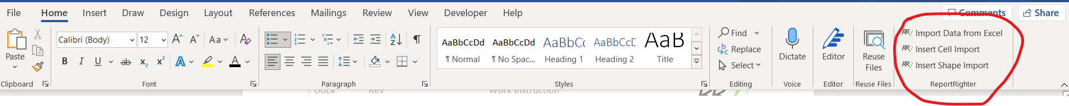
Figure 1. ReportRighter group
  - Test Case 5.2 – ReportRighter group contains all command buttons shown below:
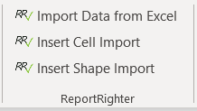
Figure 2. ReportRighter command buttons
  - Test Case 5.3 – ReportRighter group is visible in Excel.
    - The ReportRighter group can be found in the home tab of Excel. Sometimes its location on the tab differs due to other add-ins or selected displays.
Figure 3. ReportRighter group in Excel

  - Test Case 5.4 - ReportRighter group contains the command button shown below:
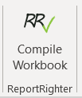
Figure 4. ReportRighter command button in Excel
- Operational Qualification
  - Some of the OQ test cases are automatic and some are manual. Automatic means that ReportRighter will display the pass/fail result in the Result column. For manual test cases, the validation engineer will need to manually indicate whether the test case passes or fails validation.
    - NOTE: Automatic does not mean that there is no action needed by the validation engineer to successfully validate. Many of the automatic test cases have instructions that need to be executed for successful validation.
  - This work instruction will go into more detail on the instructions and lay them out step by step for ease of validation. The instructions column of SVP5001 does go in order and can also be used. This work instruction is just to make it more user friendly.
- Validation Instructions
  - Open the ReportRighter Validation Workbook.xlsx and click the Compile Workbook command button in the ReportRighter group. Save and close the workbook, then open Microsoft Word.
    - NOTE: Wait until the task pane loads to save and close the workbook.
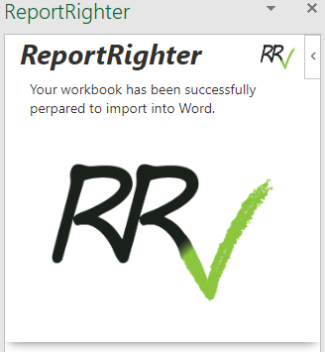
Figure 5. ReportRighter task pane in Excel
  - Highlight(select) the text in the 6.3 results cell and click the Insert Shape Import command button in the ReportRighter group. The placeholder image will be large, resize it to fit inside of the result column.
  - Highlight(select) the text in the 6.4 results cell and click the Insert Cell Import command button in the ReportRighter group.
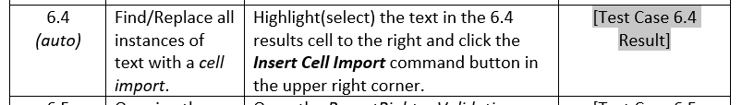
Figure 6. Highlighted(selected) results cell
  - Click the Import Data from Excel button in the ReportRighter group.
  - The import settings will be locked. Enter the password: qwerty to unlock them.
  - Scroll through the settings until you find the [Test Case 6.4 Result] menu box. Change the settings to:
    - Sheet: Test Cases 6.1-6.13
    - Cell: E9
  - Scroll through the settings until you find the [Test Case 6.3 Result] menu box. Change the settings to:
    - Shape Name: Test Case 6.3 Shape
  - Save the document, close it, and open it again.
  - Click the Import Data from Excel to reopen the ReportRighter task pane. Click the choose file button, navigate to the location of the ReportRighter Validation Workbook, and select it. Then click the Import Data button to begin importing data.
- Completing Manual Test Cases for OQ
  - Test Case 6.6
    - PASS: Test Case 6.2 Result = Pass
    - FAIL: Test Case 6.2 Result is anything else
  - Test Case 6.7
    - PASS: Test Case 6.3 Result = Pass
    - FAIL: Test Case 6.3 Result is anything else
  - Test Case 6.10
    - PASS: Test Case 6.9 Result = Pass (must be highlighted)
    - FAIL: Test Case 6.2 Result is not highlighted
- Interpreting Results
  - All test case results must pass for successful validation.
  - If any test cases fail double check to ensure that all instructions were followed properly. If validation continues to fail while following proper procedure contact ReportRighter Support at rr.help@engsuite.org. For faster and more effective support please use this format for the subject: Validation Failed – {Test Case}
    - Replace {Test Case} with the test case that failed. If more than one failed, please use this subject: Validation Failed – Multiple Test Cases
    - Please also include the validation protocol and workbook that you are using for validation so that our support team can make sure that all of the settings are correct.

